**Lab 06 Documentation MYSQL – PHP**

Anna Victoria Kerz – 300292572

* A picture containing light, drawing

  Description automatically generatedA picture containing light, drawing

  Description automatically generated**Database structure:** [1] Refer to footer for key references..

|  |  |  |
| --- | --- | --- |
| **Patients** | **Breeds** | **Owners** |
| A picture containing drawing  Description automatically generatedpatient_id | A picture containing drawing  Description automatically generatedA picture containing drawing  Description automatically generatedbreed_id | owner_id |
| patient_name | breed_name | owner_name |
| patient_dob | breed_size | owner_address |
| patient_breed_id |  | owner_city |
| patient_owner |  | owner_zipcode |
| patient_last_visit |  | owner_phone |
|  |  | owner_email |
|  |  | owner_account_balance |

* **SQL via command prompt**:

To log in as root user, type the following command:

mysql -u root

If the log in is successful you will see a Welcome message and your console will show the your location for consequent commands as mysql>

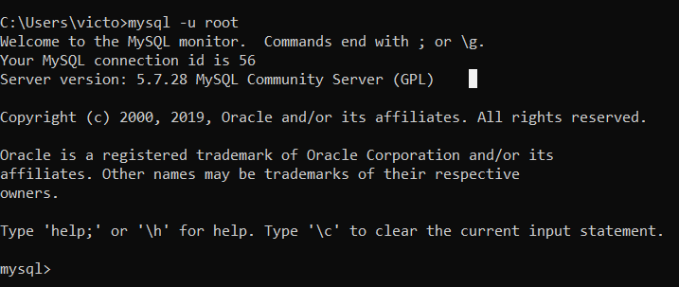

* **Source file selection:**

A sql which contains the initial commands is given, which will be sourced from the command prompt.

SQL > *Filename*: *Lab06_AKe92572.sql*

* ***What does this file do?***

1. The database is dropped if it exists previously.
2. The database is created.
3. The tables are created:

* ProductSale
* Products
* Customers

To specify the file that contains the commands for database and table creation type the following command:

mysql> source Lab06_Ake9257.sql

If the command is successful, you will see how many rows were affected by it:

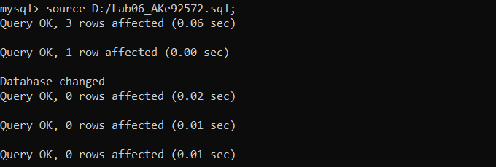

* **To see the tables and make sure they were created, type in the following commands:**

To switch to the newly created database:

**use $vet_AKe92572**

Then, request the tables to be shown:

**mysql> show tables;**

If the creation was successful, it will show something like this:

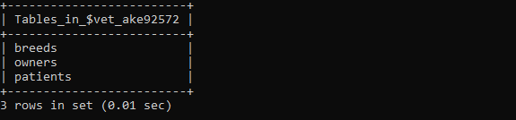

* **Database CRUD operations:**

**Create:** In this example, this is covered by running the following commands. Each command will insert entries to the three tables to populate them with data.

To insert values to the Patients table, type the following command:

**INSERT** INTO **Patients** VALUES

(0, 'Max', '2015-04-12', 5, 1, '2020-04-30'),

(0, 'Buddy', '2014-06-14', 3, 1, '2020-05-01'),

(0, 'Bailey', '2017-03-02', 1, 2, '2019-07-14'),

(0, 'Bella', '2011-08-12', 4, 3, '2016-01-13'),

(0, 'Lucy', '2011-12-19', 4, 5, '2018-07-17');

The result should show:

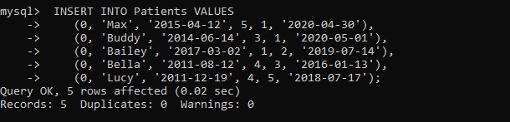

To insert values to the Breeds table, type the following command:

**INSERT** INTO **Breeds** VALUES

(0,'American Staffordshire Terrier', 'Large'),

(0,'Bearded Collie', 'Medium'),

(0,'Border Collie', 'Medium'),

(0,'English Bulldog', 'Medium'),

(0,'Cane Corso', 'Extra Large');

The result should show:

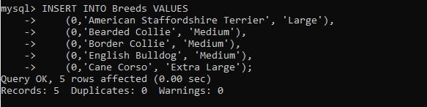

To insert values to the Owners table, type the following command:

**INSERT** INTO **Owners** VALUES

(0, 'Amber G Kirkland','733 Bank St','Vancouver','V0E 3B0',6137394584,'bms42kzrn0i@classesmail.com',512.41),

(0, 'Janice J Rowe','1417 Blind Bay Road','Westwold','T7E 6B0',2503757019,'06ic5llt62bk@classesmail.com',0),

(0, 'Tommy S Zito','1546 Yonge Street','Elko','V0B 1J0', 2505297390,'imldoe7nqp@meantinc.com',0),

(0, 'Patricia W Blackburn','14 Bay Road','Crawford Bay','V0E 1B0',2502256123,'7v9xm13ij0a@fakemailgenerator.net',1971.12),

(0, 'Jean A Ball','1972 Burdett Avenue','Victoria','V8Z 2J8',2504798988,'yg85z51p6w@powerencry.com',0),

(0, 'Rochelle L Pawlak','669 Robson St','Vancouver','V6B 3K9',6049742016,'ecj323b5a78@groupbuff.com',0);

The result should show:

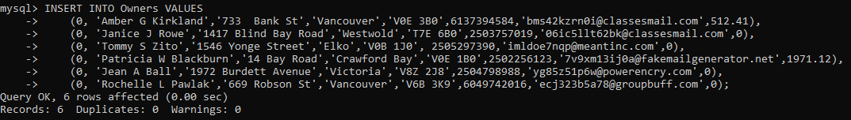

**Update:** To update an entry in a strong entity (Patients), type the following command. This will set

Bailey’s last visit date to today’s date.

UPDATE Patients

SET patient_last_visit = CURDATE()

WHERE patient_id = 1002;

The result should show that one entry was modified:

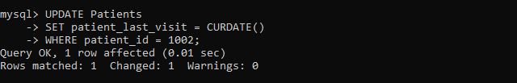

Select: The following command will join all three tables by the key identifiers, which in this case are: patient_id, breed_id and owner_id. It will display only 6 of the columns, which are defined at the beginning of the query.

To do this, enter the following command:

SELECT

p.patient_id, p.patient_name, p.patient_last_visit,

b.breed_name,

o.owner_phone, o.owner_account_balance

FROM Patients p

JOIN Breeds b ON p.patient_breed_id = b.breed_id

JOIN Owners o ON p.patient_owner = o.owner_id

ORDER BY p.patient_id;

It should display the following (note for Bailey, today’s date is set as her last visit date)

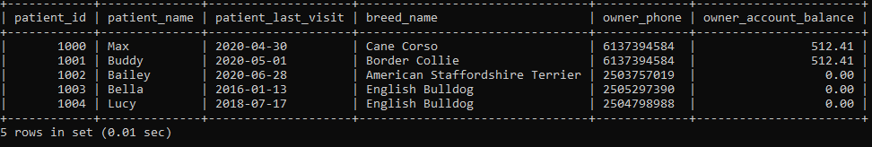

**Delete:** Lastly, to delete Lucy (1004) from the Patients table, enter the following command:

DELETE FROM Patients WHERE patient_id = 1004;

After a confirmation, if the select query is ran again on the Patients table, Lucy should no longer appear.

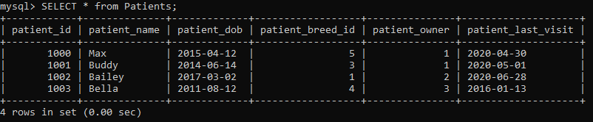

1. Icons made by [Freepik](https://www.flaticon.com/authors/freepik) from [www.flaticon.com](http://www.flaticon.com/)

   Primary Key

   Foreign Key

   Foreign Key in a table not represented in this Lab.